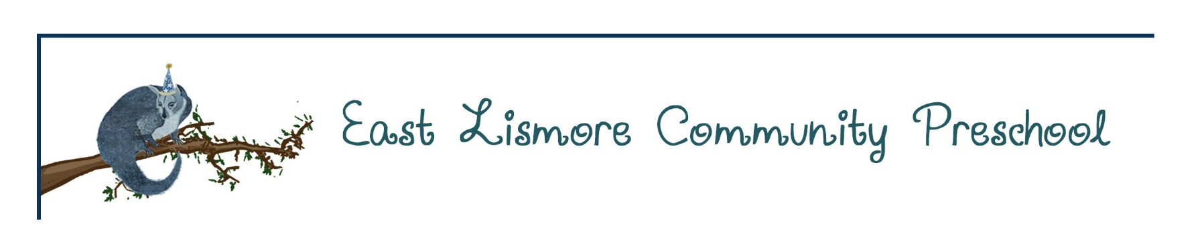

Parent Code of Conduct | Quality Area: 6
Policy Statement

To ensure positive relationships between parents/carers and members of staff that benefit each child’s learning, development and sense of security as well as to ensure mutual respect between staff and parent/carers is maintained at all times.
National Quality Framework
Standard 6.1
Element 6.1.1
Element 6.1.2
Standard 6.2
Element 6.2.2

Aims

ELCP Preschool requires that parents/carers of enrolled children behave in a manner consistent with our Philosophy so decency, courtesy and respect occur at all times, especially where there may be a disagreement. One of our most important goals is to provide the most appropriate and secure environment for children that encourages growth, learning and development. Achieving this ideal environment is not only the responsibility of employees and committee members but it is also the responsibility of each and every parent or adult who enters the school.

Strategies
We are a close family-like community and the preschool is aware that staff and parents have relationships outside of the classroom setting. Employees and parents/carers will also be in regular attendance at shared community events. It is important for any personal conflicts or disagreements to be kept outside of the preschool. The preschool shall be a calm and positive place for children at all times. Any concerns a parent/carer may have regarding a member of staff will be listened to outside of the classroom and where needed acted upon. However, it is both the parent’s and the staff member’s responsibility to ensure that personal disagreements must be kept outside of the classroom setting.
No parent or adult shall be permitted to swear or use any other inappropriate language when in the classroom or playground. Such language will NOT be tolerated in the presence of the children or preschool staff.
Threats and Confrontation: Threats of any kind toward ELCP staff, committee, other parents or children will not be tolerated. While it is understood that all parents may not agree with the staff Op or the parents of other children, it is expected that all disagreements be handled in a calm and respectful manner. Confrontational interactions are not an appropriate means by which to communicate a point and are strictly prohibited. Shouting, raising of voices or any unwanted physical contact with a member of staff is considered inappropriate behaviour. If you have concerns about something that is occurring in regards to your child we ask that you first raise it with a staff member from their room. Please follow our feedback and complaints process for all concerns about the educational care your child is receiving.

Process

Parents/carers must never attend the home of a staff member without prior permission from the staff member.
If it is deemed that a parent is acting in an inappropriate manner to a staff member or parent, the following steps will be taken:
- A meeting with the parent/carer, Director and or a Committee member will be held to outline the issues or concerning behaviour and attempt to find a resolution to the problem.
- A follow-up letter on the outcome of the meeting will be sent to the parent/carer to ensure a clear understanding has been documented.
- If no resolution has been found and the parent continues to act in a manner that is inappropriate to these guidelines the decision may be made to place the child’s enrolment on hold and make a formal request that the parent and child leave the preschool. With this code of conduct in place, we hope to provide your child and family with a supportive and safe environment as we help set up great role modelling for all children.

Authorisation.
This policy was adopted by the Approved Provider of East Lismore Community Preschool at the committee meeting on 6th December 2022.

